**UOG, Tokyo University test a virus on Guam’s rhino beetles**

An experiment is underway between the University of Guam and the Tokyo University of Agriculture & Technology (TUAT) to discover if a virus that infects coconut rhinoceros beetles in Palau can also infect the rhino beetle type specific to Guam. And if so, the experiment will reveal if the virus affects the beetle’s ability to fly, eat, and reproduce — three functions contributing to its detrimental impact to Guam’s coconut palms.

“Nobody has done this test yet — believe it or not,” said Dr. Aubrey Moore, an entomologist with UOG’s Cooperative Extension & Outreach service. “Nobody has been able to get the funds to get a population of CRB-G and CRB-S, dose them with the same virus, and see what the differences are.”

The CRB-G is the genotype of rhino beetle in Guam. More than 10 years ago, [UOG or who?] researchers found Guam’s beetle type was genetically different from other known rhino beetles, which are collectively referred to as CRB-S. CRB-G is also found in other parts of Asia, including Japan and the Philippines, although it’s largely only considered a pest in the tropics, where the beetles like to bore into coconut palm trees to feed on the sap.

“We’re trying all kinds of different strains of the virus hoping to find one that matches our beetle,” Moore said. “The one we’re testing [now] is from Palau. It doesn’t seem to kill our beetles, but we’re wondering if there are some sublethal effects. That would be really important. You don’t have to kill an insect to control it. If you can stop it from feeding or flying, that will reduce its damage.”

Funding from a U.S. Forest Service grant and a Department of the Interior Office of Insular Affairs grant as well as a new student exchange agreement signed this year between the UOG College of Natural & Applied Sciences and TUAT have allowed the experiment to take place.

As the first exchange student of the new partnership, Mayuho Yamauchi, who will soon begin a Ph.D. program specific to the Oryctes rhinoceros beetle at TUAT, spent this past March in Guam designing the experiment with Moore and collecting data. Her advisor is Dr. Madoka Nakai, an insect virologist who has been visiting Guam and working with UOG for the past 10 years to find a biological control for the CRB in Guam.

The experiment involved feeding the virus to a group of CRB-G and a group of CRB-S and monitoring their eating, flying, and reproduction rates and comparing them to two control groups of each beetle type that did not receive the virus. Each beetle was numbered and their activity recorded. Yamauchi dissected each beetle to obtain a gut sample that she can now take back to a lab at TUAT and test it for the virus. Then they can compare whether infected beetles behaved differently or died sooner than the non-infected beetles.

“There’s no guarantee that this Palau strain is the one we’re looking for. We’re hoping it is because the damage in Palau is much, much less than here,” Moore said.

He said the virus was discovered in the 1960s, and since then, islands including Palau, Fiji, and Tonga have successfully reduced the damage of rhino beetles by introducing the virus.

From their initial data and observations, they didn’t notice any difference in behavior between the groups that were fed the virus and those that weren’t. Moore said his assumption is that Guam’s genotype of CRB is resistant to this particular strain of the virus.

* When will Mayuho have the results from the virus tests?
* What will it mean for Guam if the beetles were actually infected? What will it mean if they weren’t?
* How many other strains of virus are there that could be tested? Would you use this same experiment each time?
* Considering funding and the number of viruses to be tested, how long do you think it might take to find one that works?

“Almost definitely it will be a form of this virus that will help us control the problem,” he said.

**PHOTO CAPTIONS**

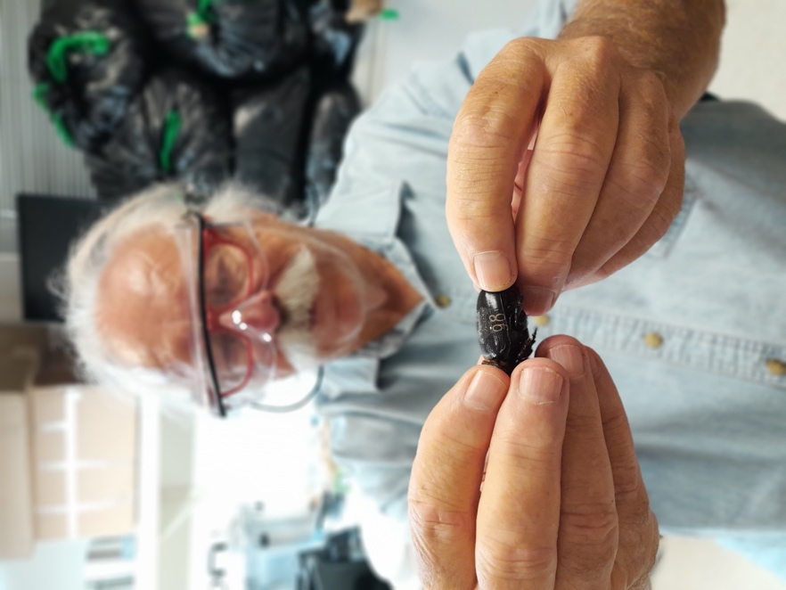

Dr. Aubrey Moore holds a freshly laser-engraved number on a coconut rhinoceros beetle. The engraving allows him to keep data on a large number of beetles’ behavior in the weeks after they’ve been fed a virus. Moore is testing viral infections as a potential biological control for Guam’s invasive rhino beetles.

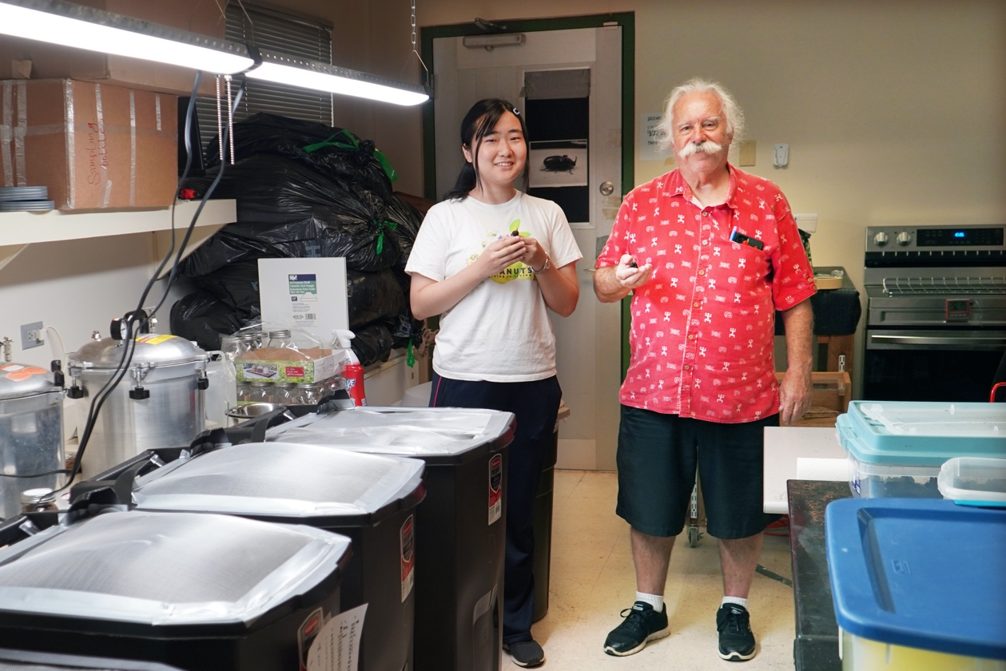

Mayuho Yamauchi, a graduate exchange student from Tokyo University of Agriculture & Technology, and University of Guam entomologist Dr. Aubrey Moore stand by containers they’ve outfitted to test the effect of a virus on rhino beetles’ ability to fly.

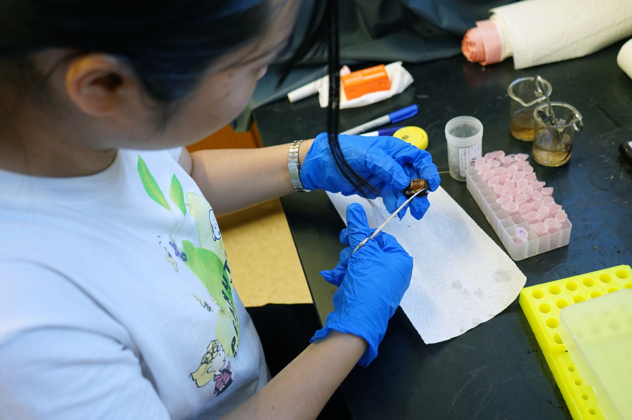

Mayuho Yamauchi, a graduate exchange student from Tokyo University of Agriculture & Technology, dissects a Guam rhino beetle. She is removing the guts of the beetles in her study so she can conduct a lab test back in Tokyo and see if they were successfully infected with a virus that was fed to them.

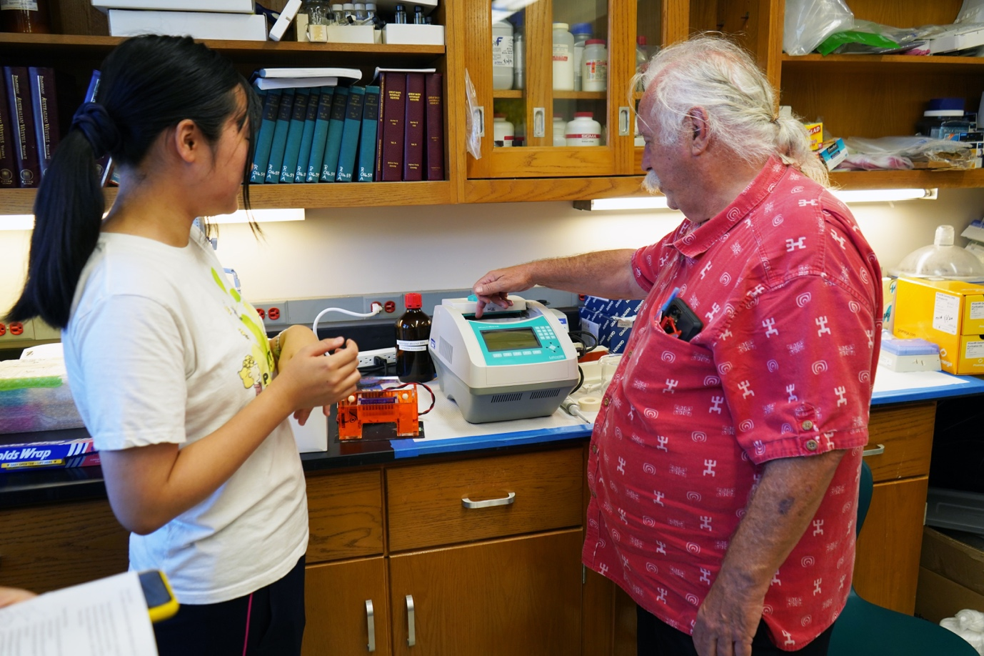

Mayuho Yamauchi, a graduate exchange student from Tokyo University of Agriculture & Technology, and University of Guam entomologist Dr. Aubrey Moore use a ____ machine to _____.